# Screens

## Main Screen

This screen shows the user their saved teams. It uses a grouped list to separate current and past teams. Each team shows the team name, division name, current record, and if notifications are on for a current team. Clicking on a team brings the user to that team’s schedule page. Long pressing (Android) or swiping (iOS) a team reveals Edit and Delete context actions. The Add Teams button takes the user through the Add Teams workflow. The menu button opens a menu on the left side of the screen

**Main Screen**

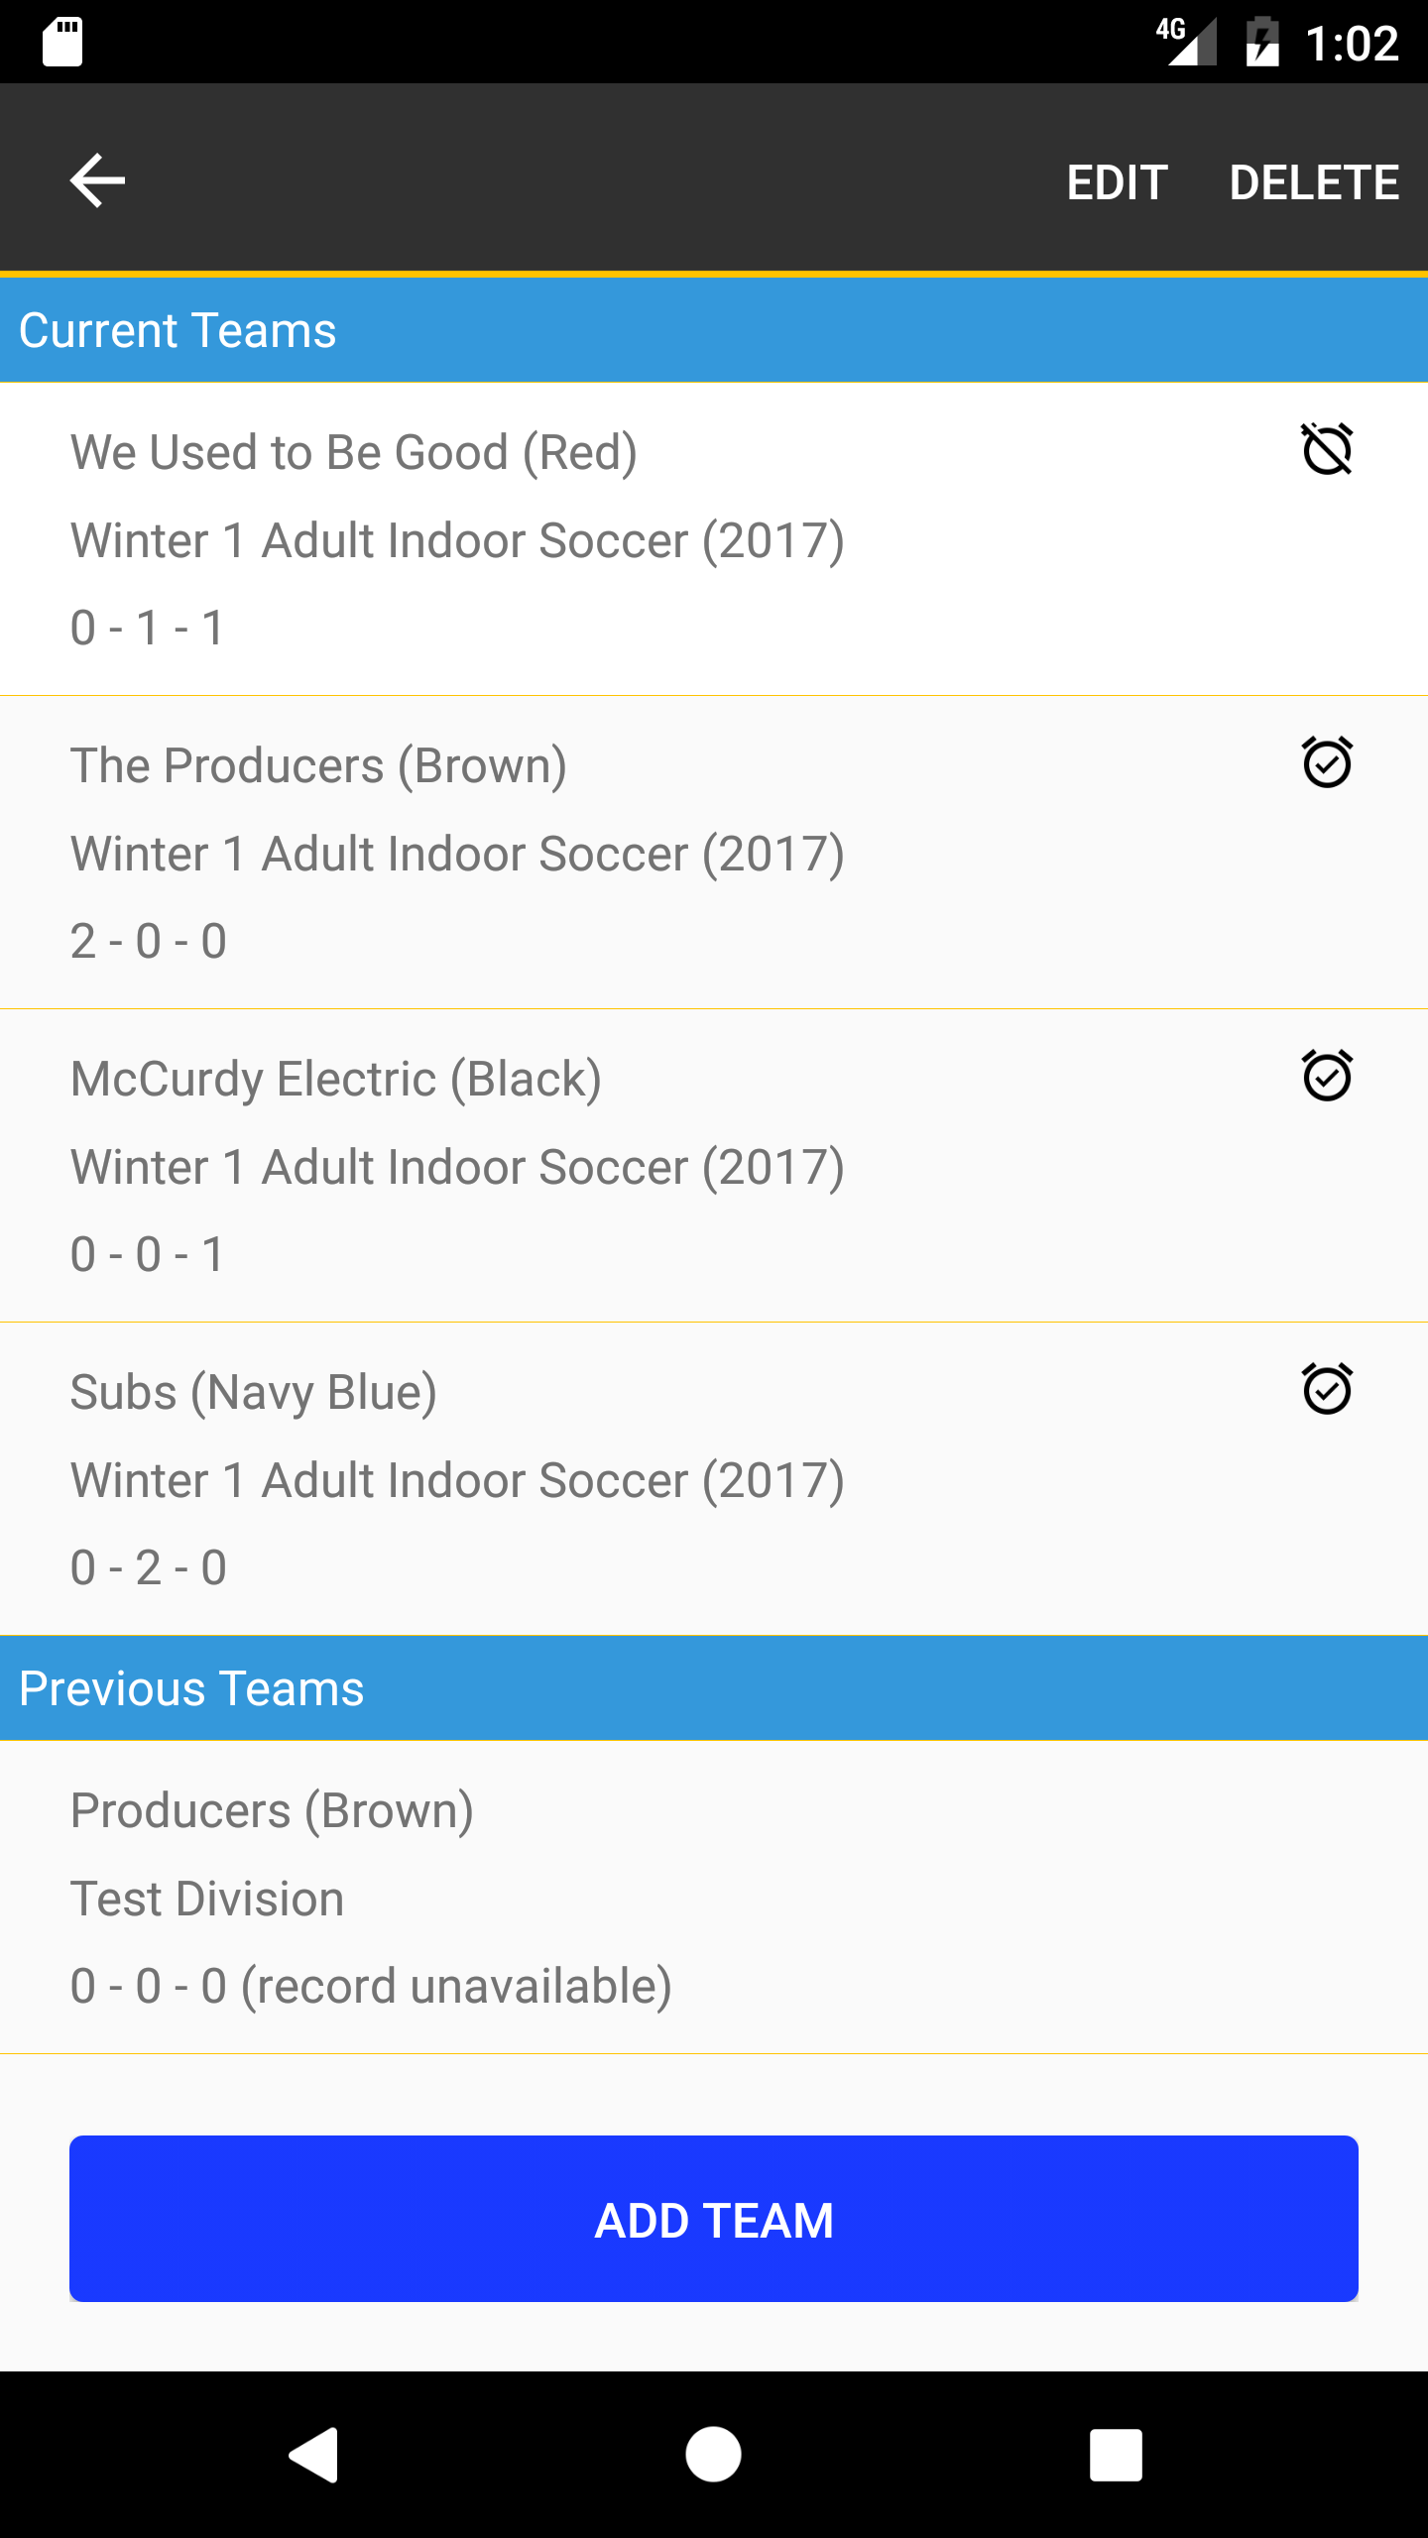

**Main screen with context actions (Android)**

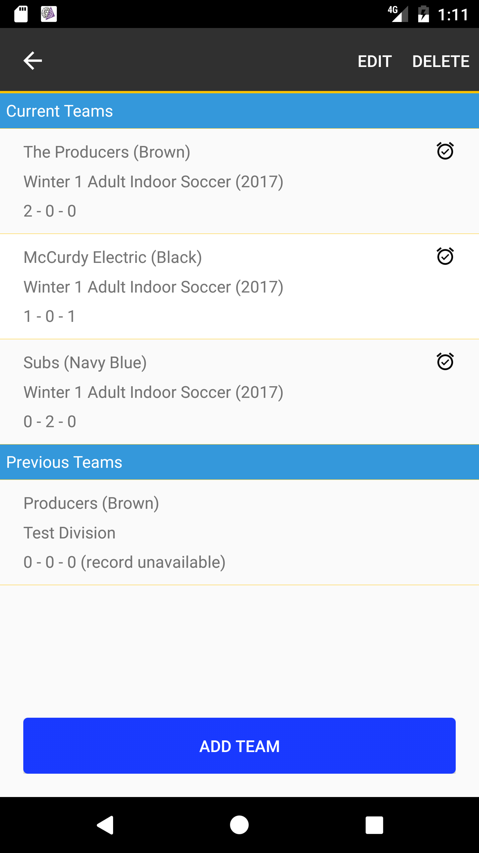

**Main screen with menu**

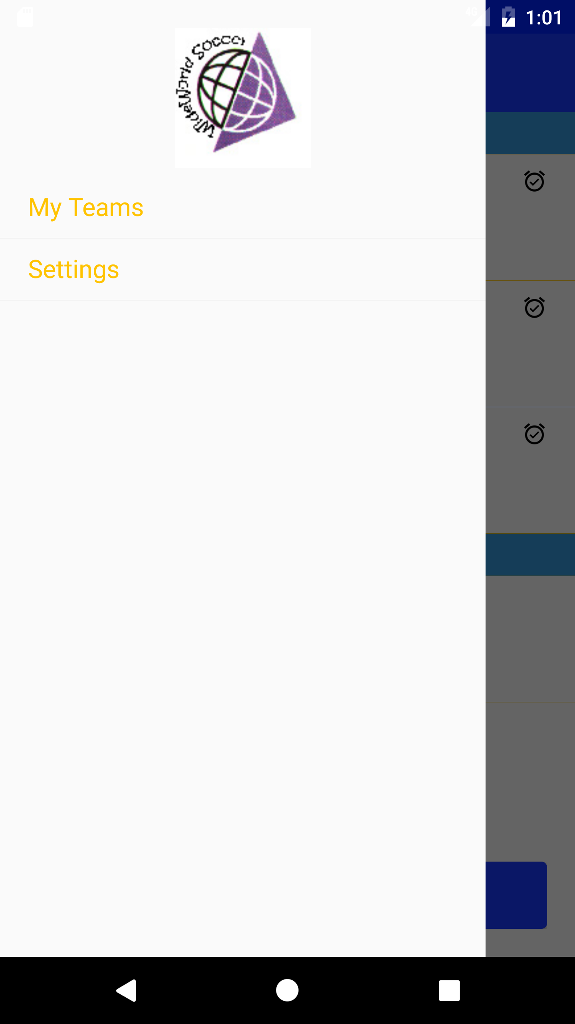

## Add Teams Workflow

The user can add teams to their schedule. They’re taken to a screen that allows them to select their team by choosing Season, League, Division and finally Team from pick lists. Each list appears as the previous one is selected. Once all fields are selected, the user can view the team’s schedule. On the team schedule screen, the user can choose to save the schedule to their phone. If they do, they are asked if they want notifications for the team’s games.

**Select Team (initial)**

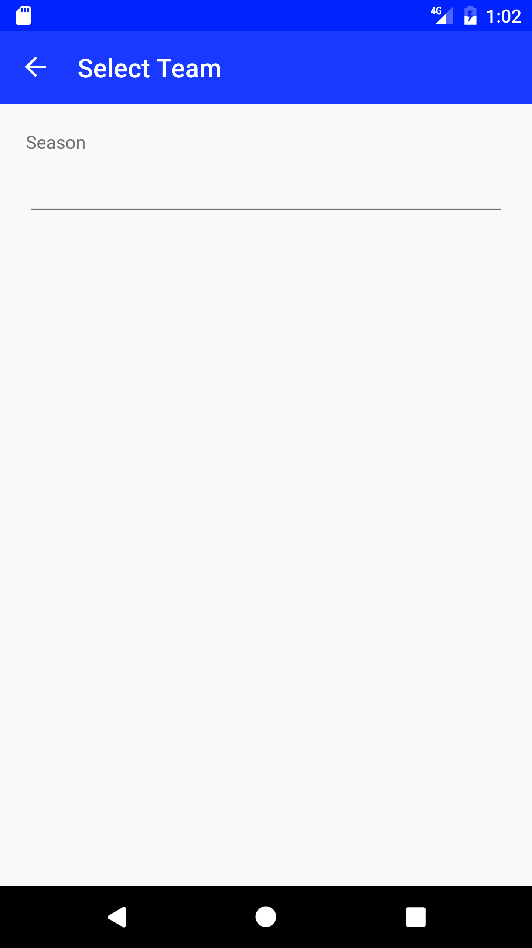

**Select Team (picklist clicked Android)**

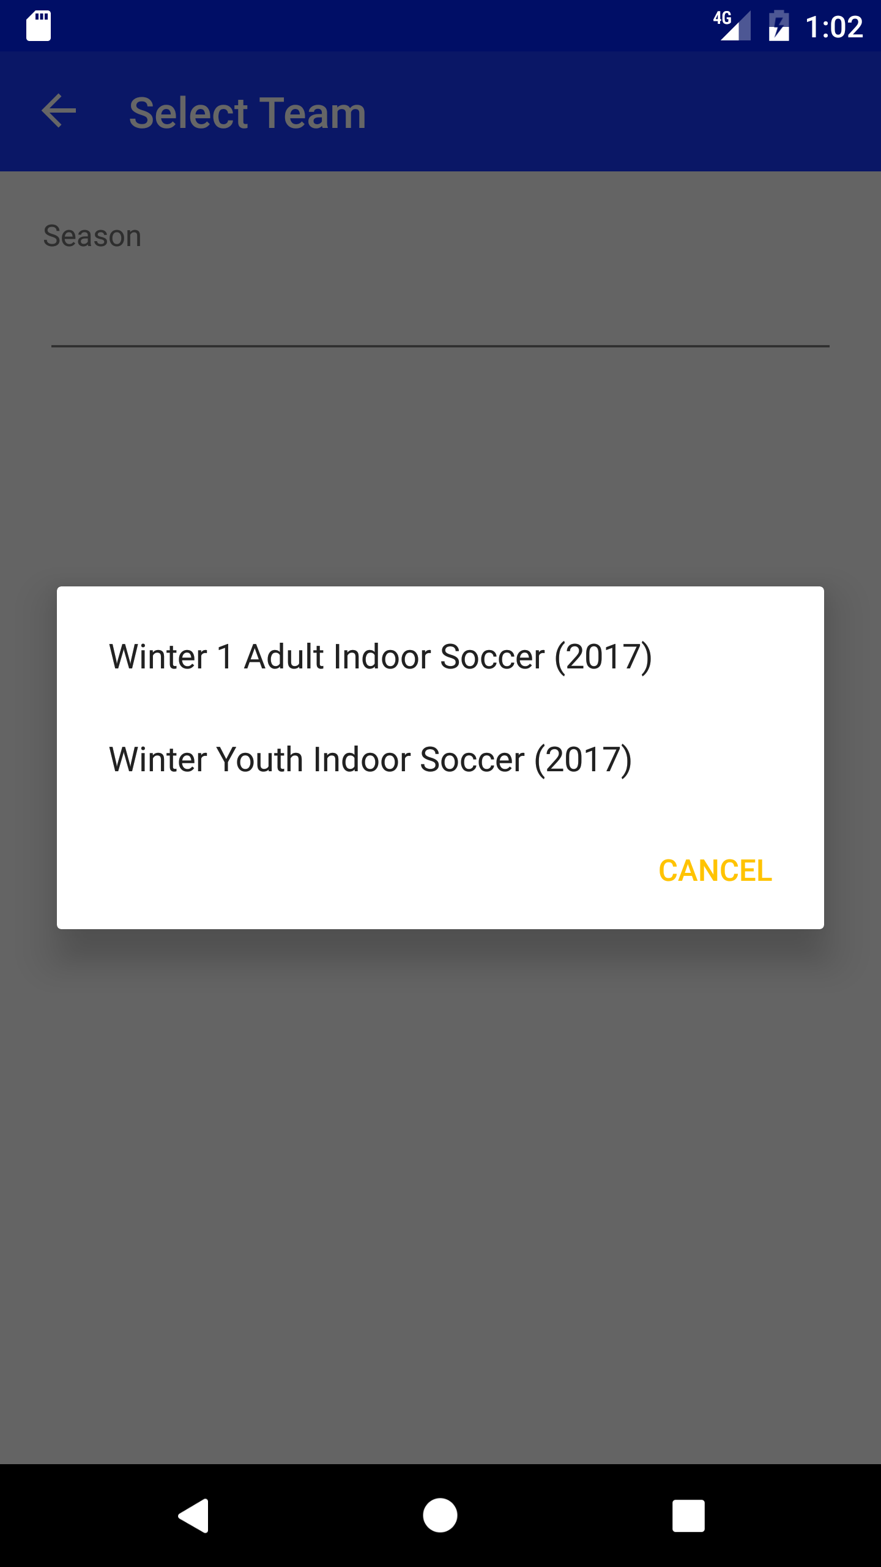

**Select Team (all fields populated)**

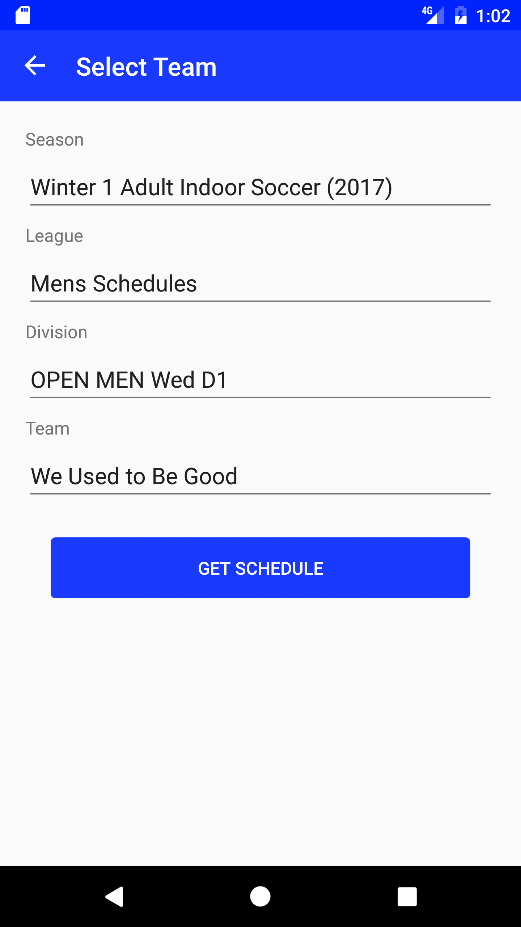

**Team Schedule**

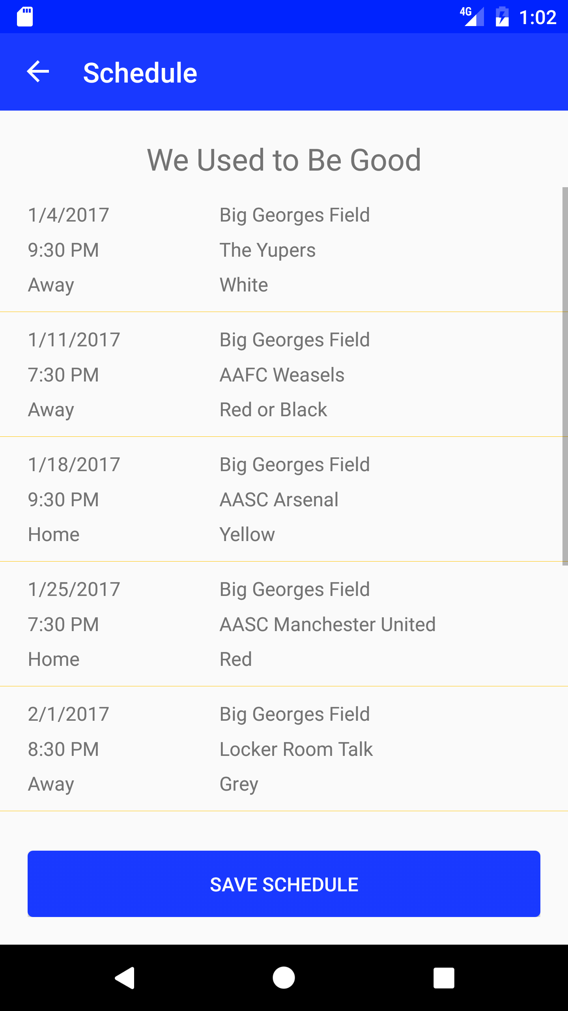

**Team Schedule (notification prompt)**

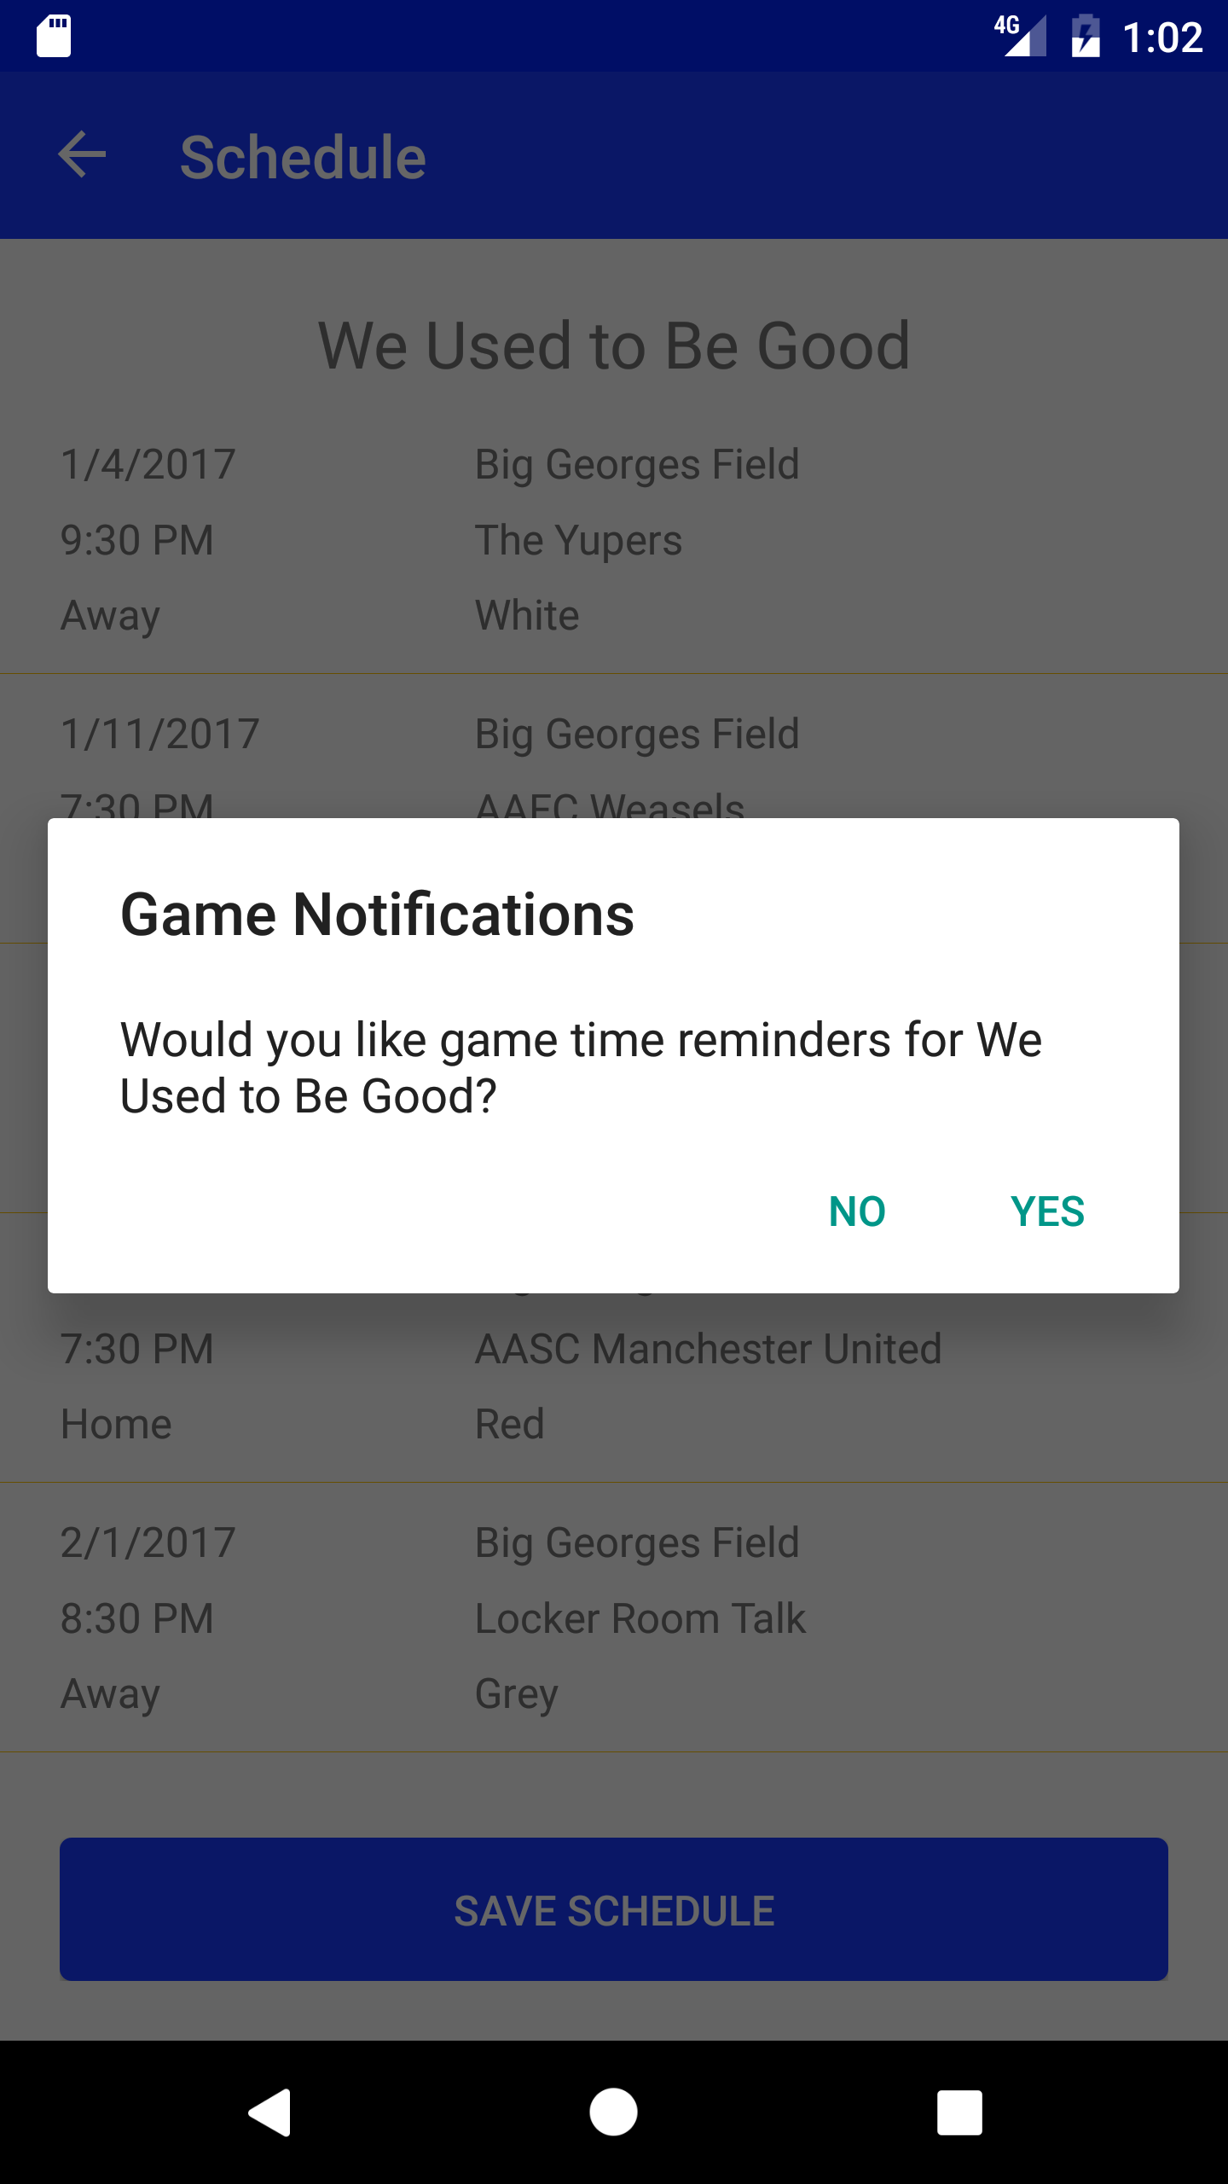

## Saved team schedule

The user can see the schedule for their saved teams by clicking on the row on the main screen. The schedule has a couple row type variations based on available information: Past game (displayed with a gray background), Future game (white background), Score Known (4 rows of information in cell), Score Unknown (3 rows of information in cell). Past games can be either Score Known or Unknown. Future games can only be Unknown.

The information shown on the cells is:

|  |  |
| --- | --- |
| Game Date | The field the game is played on |
| Game Time | Opponent name |
| Home / Away | Opponent color |
| Score (if known) |  |

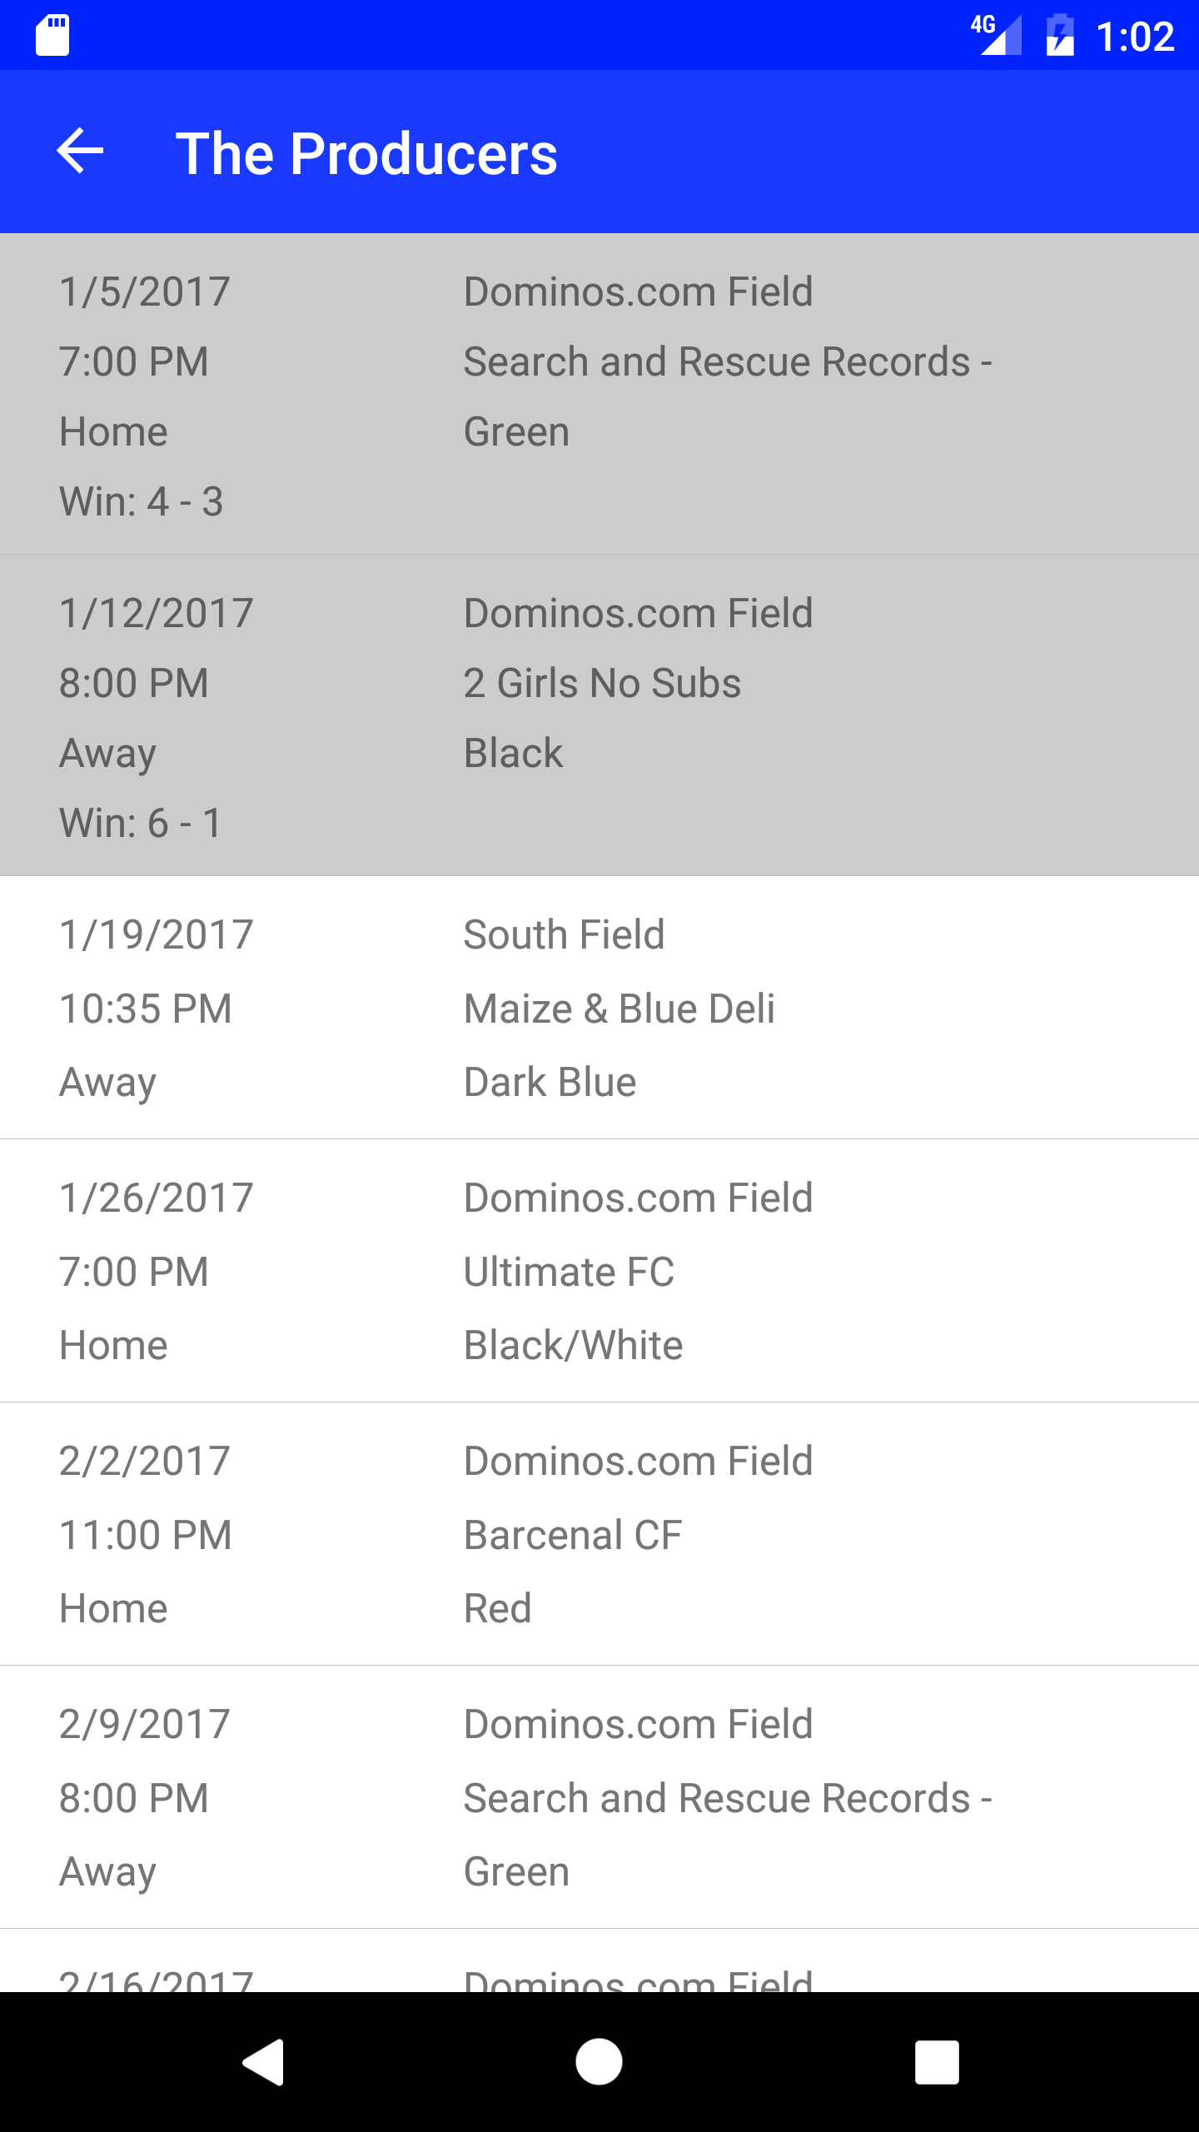

## Settings

The user can change a few notification preferences for the application. They can toggle whether they want to see Game Notifications, Schedule Change Notifications, and New Season Notifications. If they allow Game Notifications, they can choose when to notifications. They can choose any hour AM or PM, and whether they want to see the notification on the day of the game or the day before the game. All changes to this screen are saved immediately.

**Settings**

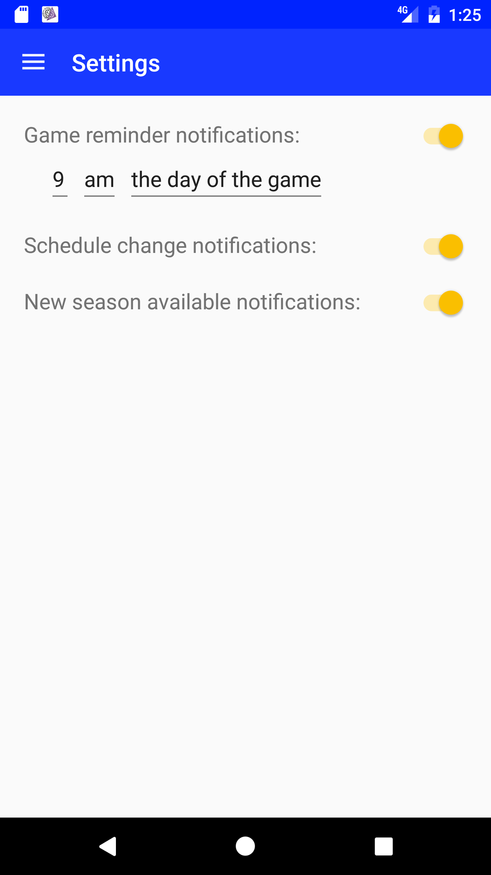

**Settings picklist (Android)**

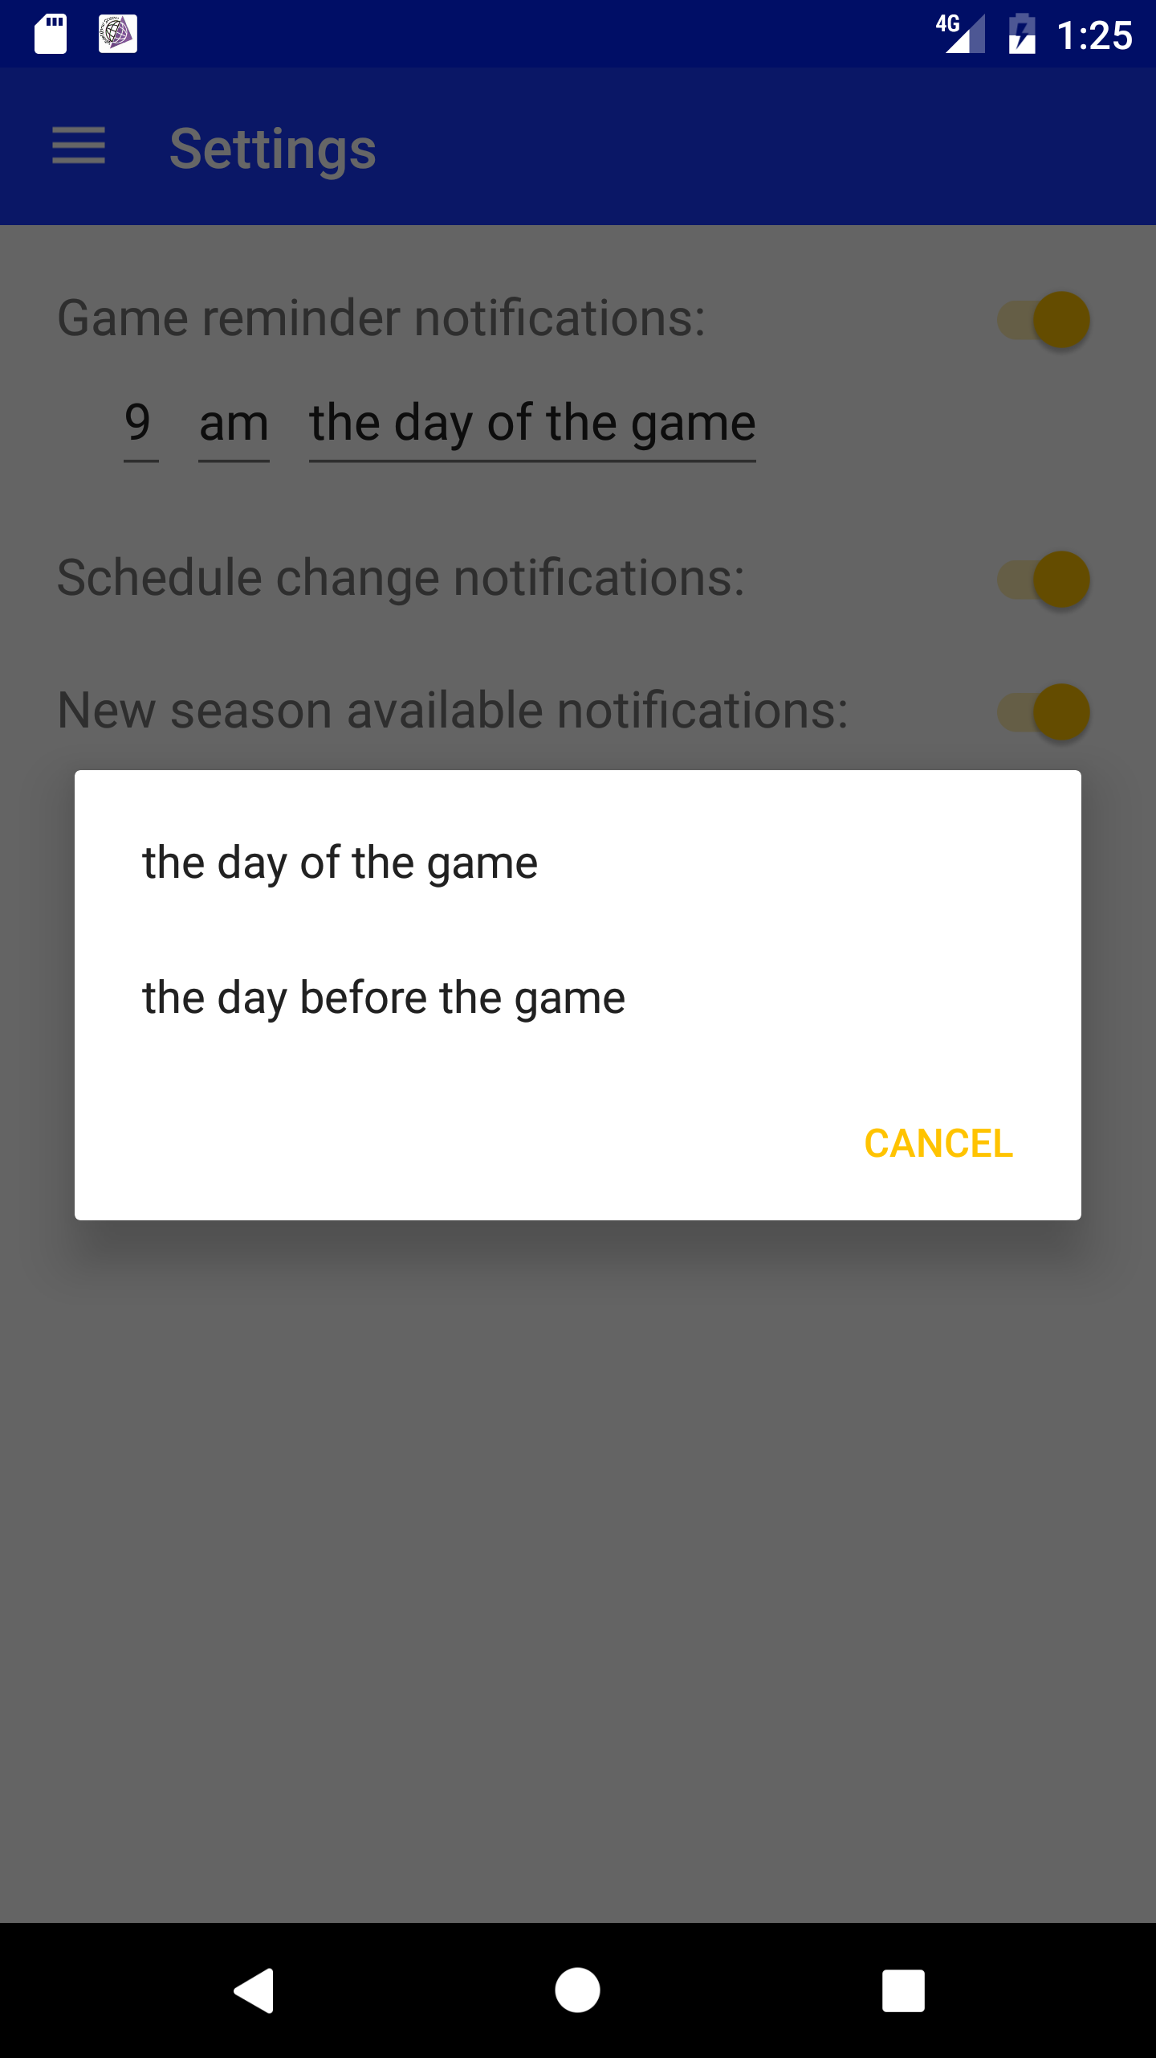

## Notifications

Based on their preferences, the user may receive notifications about Game Times, Schedule Changes and New Seasons. The notifications are delivered natively on the device

**Notification in bar (Android)**

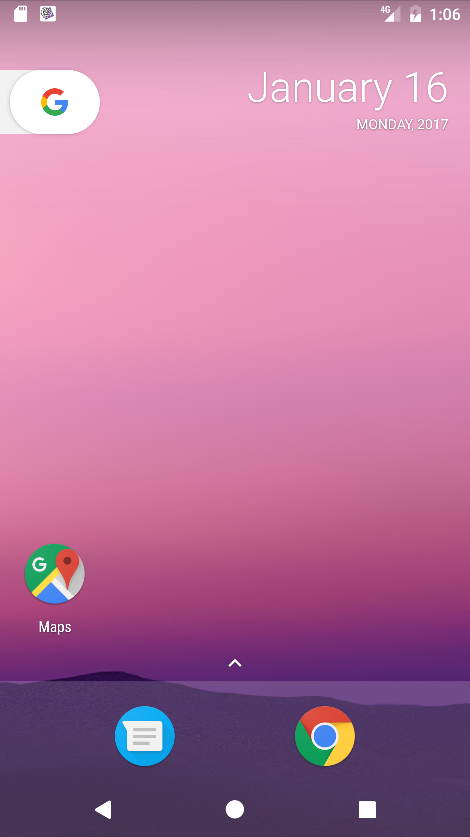

**Notification expanded (Android)**

